Omani Frankincense Burner Majmar

Author: Jenan Mahmood

Overview and Purpose of Lesson Plan
- Students will be introduced to frankincense burners (majmars), and paint their own burners while they learn about the significance of frankincense to Oman’s history and culture.

Performance Objectives
- To understand what frankincense is, its historical significance and how it is used in Oman today.
- To understand what goods were commonly traded throughout the Indian Ocean during the ancient and first global eras in general, with particular focus on frankincense trading.

Teaching Methods
- Demonstration
- Visual Instruction
- Hands-On Learning
- Class Practice
- Large Group Instruction
- Individualized Instruction

Teacher Background
- Teacher will need background information about the Omani majmar and frankincense
- Students should be able to locate Oman on a map

Accessibility Notes
- Display different images of frankincense burners to students. Ask students to contemplate the design for several minutes.
- Play traditional Omani music in the background while students examine the painted artwork. What feelings does the artwork solicit in the students? How does it fit with the rhythms of the music?
- Ask the students to express what they think about the artwork? Have the class discuss their responses to the majmar and the effect it has on their interpretation of the artwork.

Trade in the Indian Ocean

Trade across the Indian Ocean was different from any other trading network in the premodern world. What made the Indian Ocean different was the monsoon. Monsoon, meaning "season of winds" (from the Arabic word mawsim), is a seasonal phenomenon in the Indian Ocean. The Northeast monsoon winds carried travelers to the east during the spring while the Southwest winds, starting in August, helped sailors return home. These two prevailing winds meant that sailors could navigate across the Indian Ocean with far more certainty and reliability than anywhere else in the world. The ease of movement across the Indian Ocean allowed more goods to be traded across the Indian Ocean than any other ocean in the world. Commodity and luxury goods from East Africa, Arabia, India, and Southeast Asia were all exchanged. One of the most prized luxury goods traded across the Indian Ocean was frankincense.

What Is Frankincense?

Frankincense is the dried tree sap of the frankincense tree. Most frankincense is grown in the Dhofar, Oman's southernmost province and has been produced there for thousands of years. Frankincense trees thrive in Dhofar's dry environment with the trees receiving their moisture primarily from the summer monsoon each year.

Frankincense has been harvested in the same manner for thousands of years ago. Farmers first slice the bark of the tree, which allows the milky sap to run. Thereafter, it is left to dry for ten days and then scraped off. Once removed, the frankincense is bagged and sold in markets. Today, Dhofar’s old markets, most notably in Salalah, still house some of the only frankincense markets in the world, where Omanis sell and buy frankincense by the kilo.

The resin from the frankincense tree is burned for its pleasing aroma. Aside from being burned as incense, frankincense is also used in toothpaste, deodorant, and as a drink flavoring. Frankincense is also used as a bug repellent. In addition, modern studies have begun to investigate the health properties of frankincense which include possible anti-carcinogenic and anti-inflammatory properties.

The Land of Frankincense was declared a UNESCO World Heritage Site in 2000.

Omani Frankincense Burner Majmar -A Brief History

The majmar is a traditional piece of Omani pottery, usually round or square, which is painted with colorful designs. The majmar industry has been around for thousands of years in Oman. Majmars were sacred vessels and were used to offer up the pure white smoke of frankincense to the gods in what is today Rome, Greece, and Arabia, as well as parts of Asia and Africa. Frankincense was one of the most valuable items in the ancient world and was worth more than its weight in gold. Examples of ancient majmars can be found today in the Museum of Natural History in New York City, the British Museum in London, and the Louvre in Paris.

Majmars are found in every home in Oman and are a symbol of Omani culture and hospitality. Omanis burn frankincense in majmars on a daily basis to welcome guests and offer them frankincense's pure white aromatic smoke. In addition to being found in every Omani home, large majmars are used as monuments and landmarks throughout Oman.

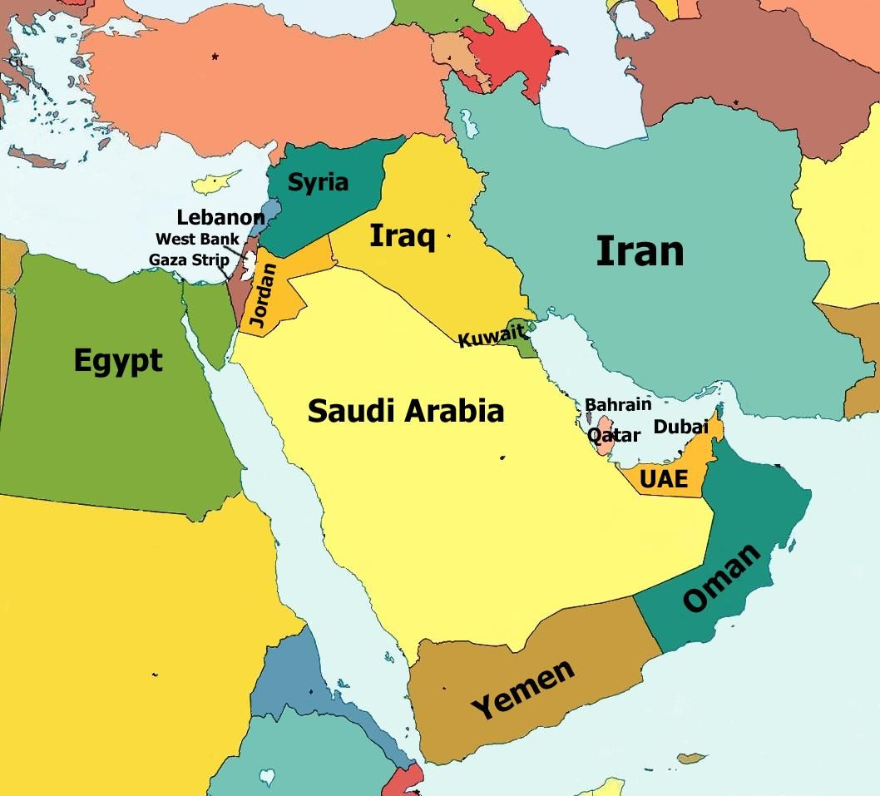
Oman Borders and Neighboring Countries
How to start painting?

Follow the instructions below or watch this video
https://youtu.be/KV90AI3C3eE

- Put a plastic sheet on the table you are using for the painting activity
- Bring water in plastic cups, one cup for each student
- Teachers to print out colorful pictures of majmars and put them on tables

Kit Includes:
- Replica
- 2 foam plates
- Paintbrush
- Sponge
- Paint bottles

How to Paint:
- Open the box and take out the replica majmar, plate, thin brush and the makeup sponge.
- Shake each paint bottle thoroughly.
- Pour a small amount of brown color on the plate.
- Use the makeup sponge to paint the whole majmar brown. Note that the original majmar is made of clay. Painting the majmar brown mimics the color of the clay.
- Pour small amounts of other colors on the other plate as needed.
- Use the brush to decorate the body of the majmar with other colors, using either the designs or motifs provided to you or create your own contemporary or traditional designs.
- Dip the brush in the cups to clean off the remaining paint and use the same brush for other colors.
- Gently wipe the brush back and forth over a paper towel to get rid of the remaining color.
- Change the water from time to time if needed.
- If you messed up the design on any spot of the majmar, you can always cover that spot with more brown paint and start over.

Note: This replica is meant for decorative purposes only. Do not burn anything in it.

Pictures on How to Start Painting

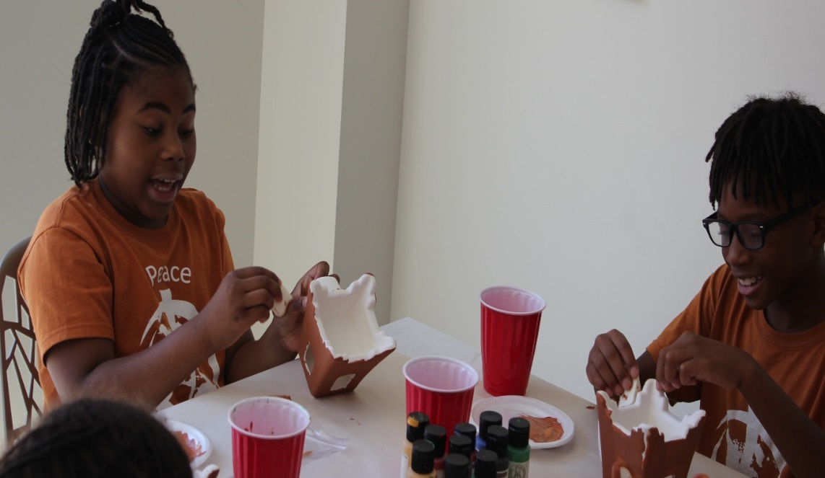

Use the makeup sponge to paint the whole majmar brown, mimicking the color of the natural clay.

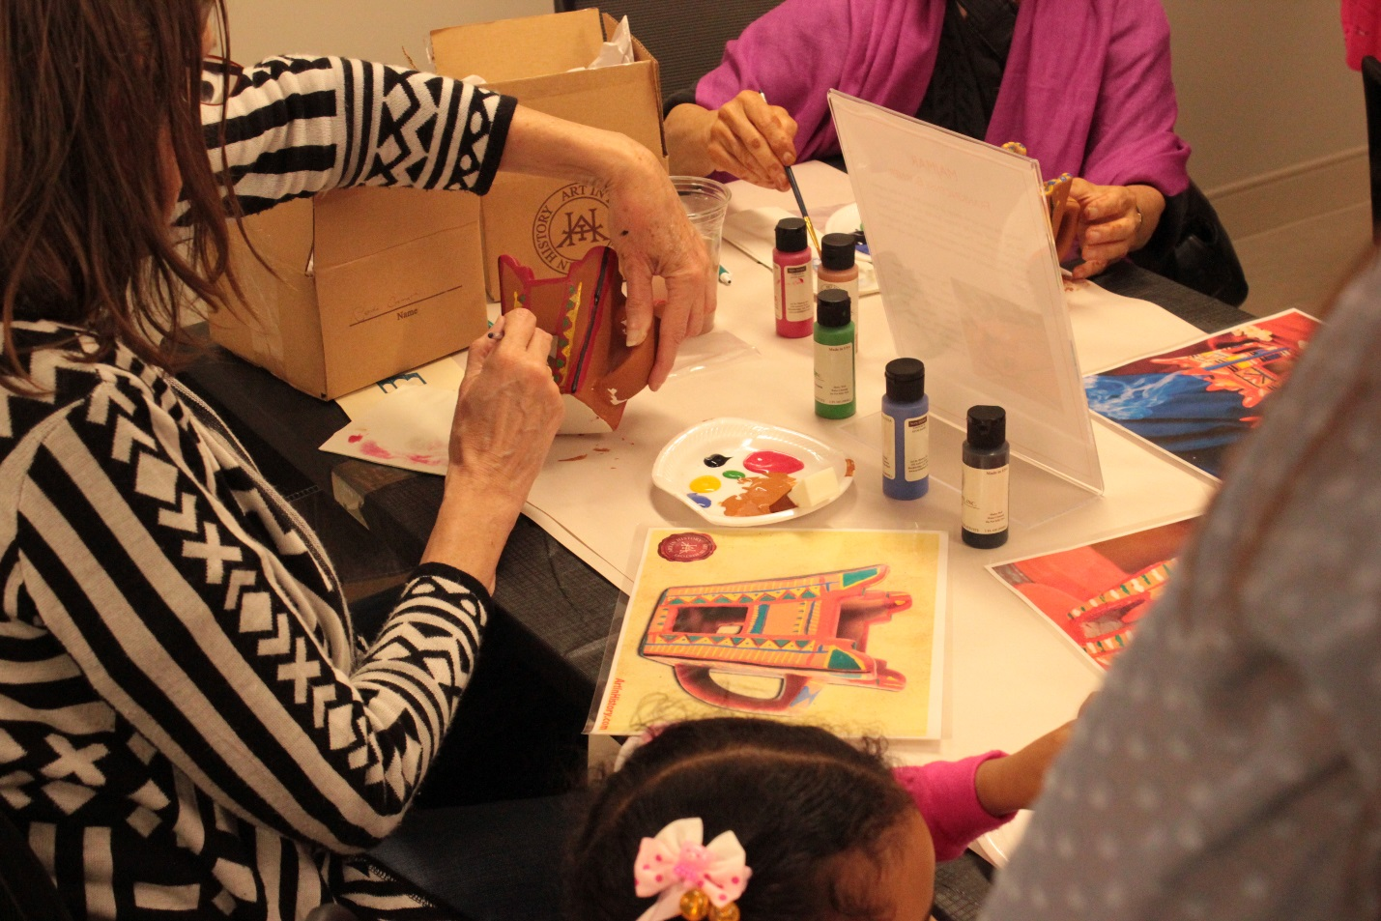

Pour small amounts of other colors on to the plate as needed. Use the brush to decorate the body of the majmar with other colors. Use either the designs or motifs provided to you or create your own contemporary or traditional designs.

